Advanced Software Engineering

Take home exam

Gift Finder App

Description of GiftFinder App:

I have created a web application in responsive to mobile app by using responsive CSS , so that look and feel of a web app is same as mobile app.

1. Design

a. Class diagram for Gift Finder App:

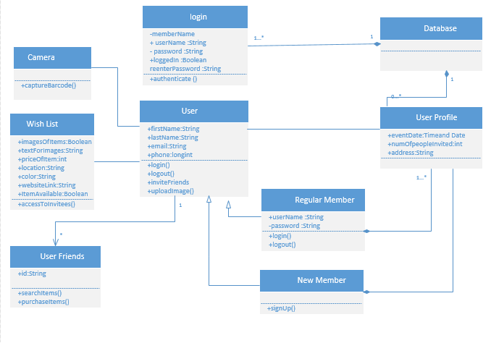

b. Architectural diagram for Gift Finder App:

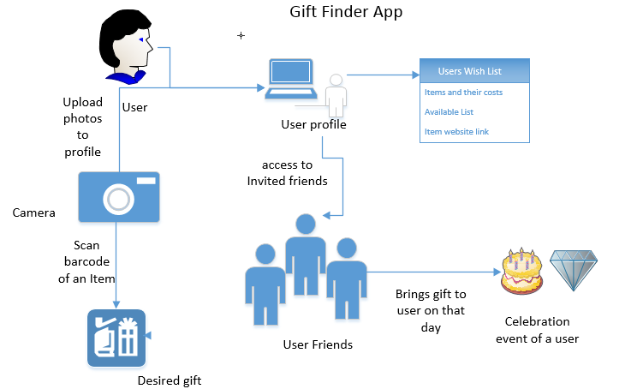

2. Features Implemented:

b. Own Data Model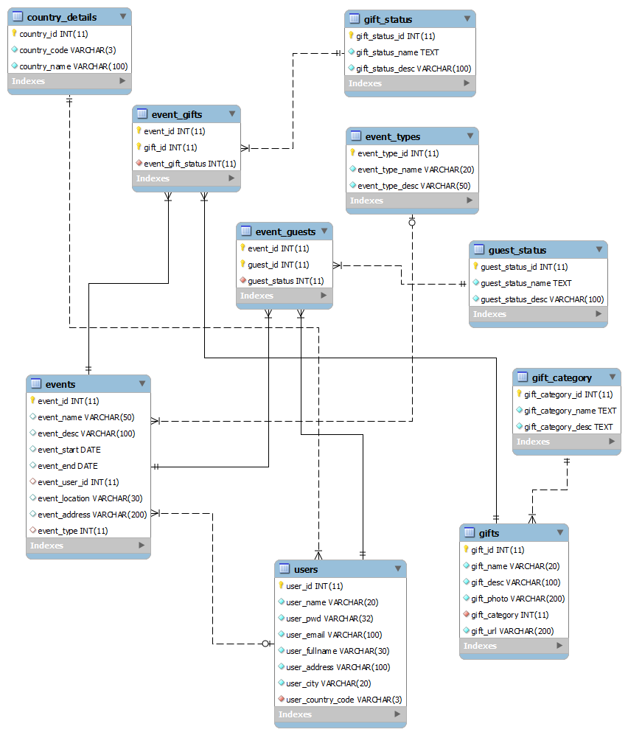

c. Mobile User Interface:

i. Own Design:

Screenshots:

The login page I have created using HTML file .

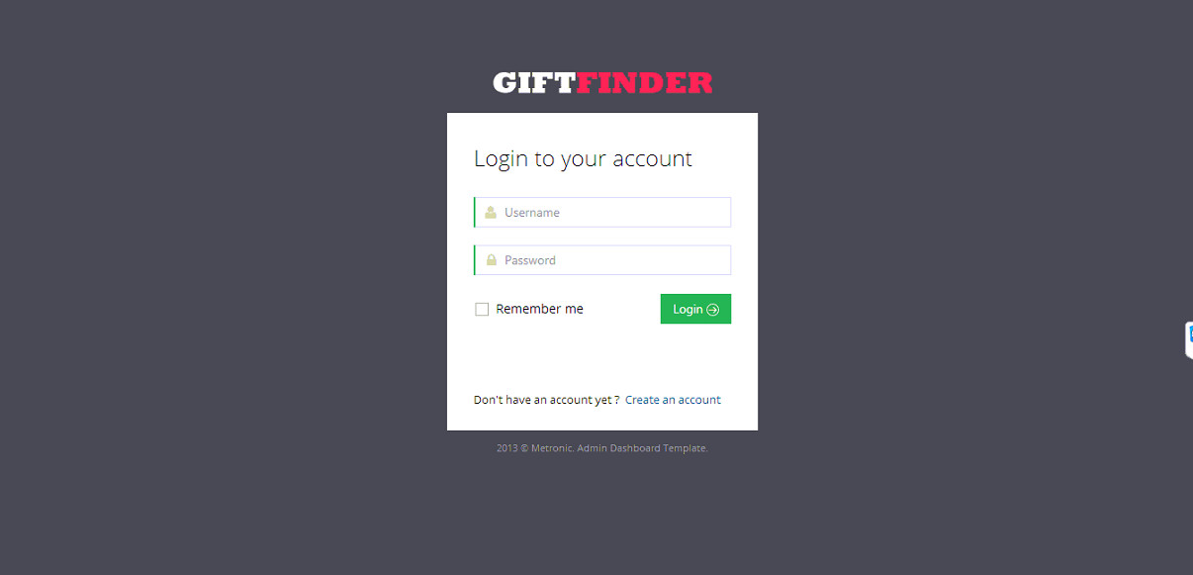

If the user is new , then he needs to signup as follows.

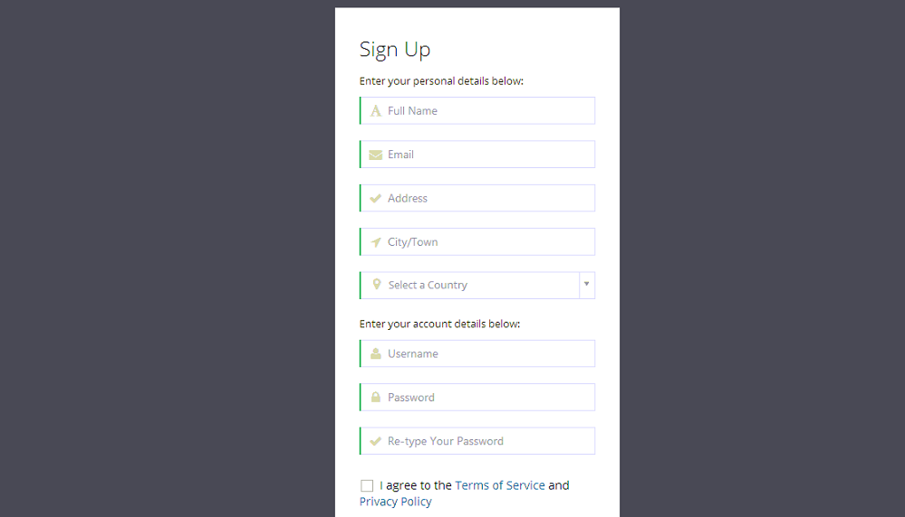

The Signup page with validations.

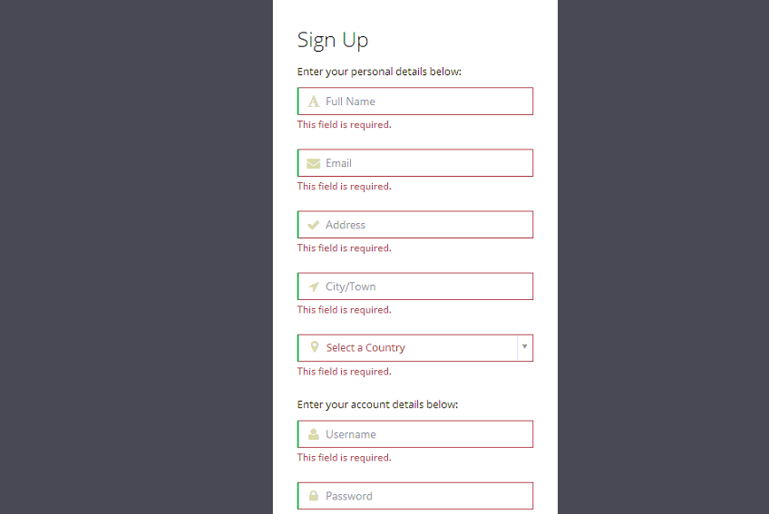

Then after entering the details need to signup.

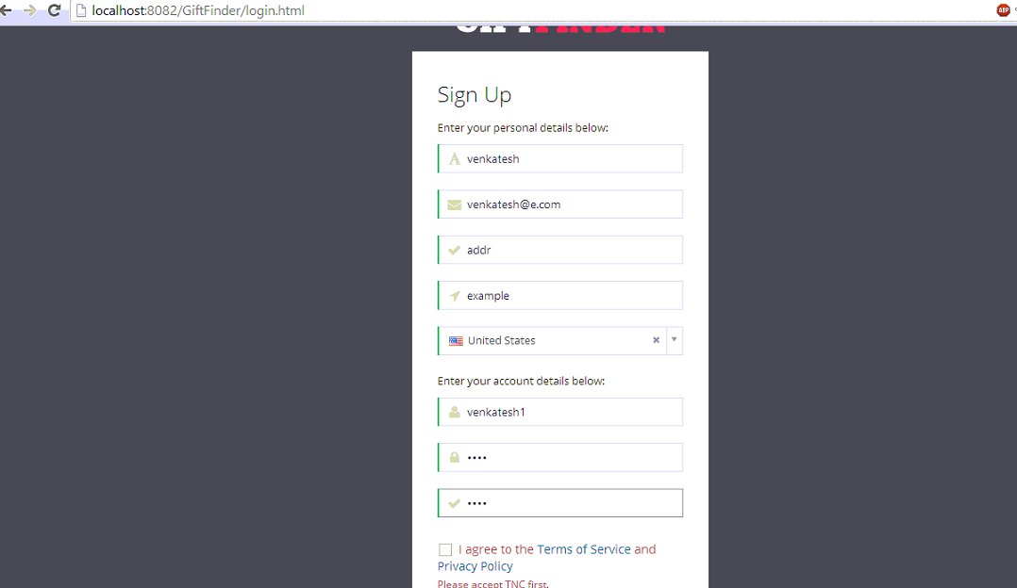

Then after successful registration we login with the details.

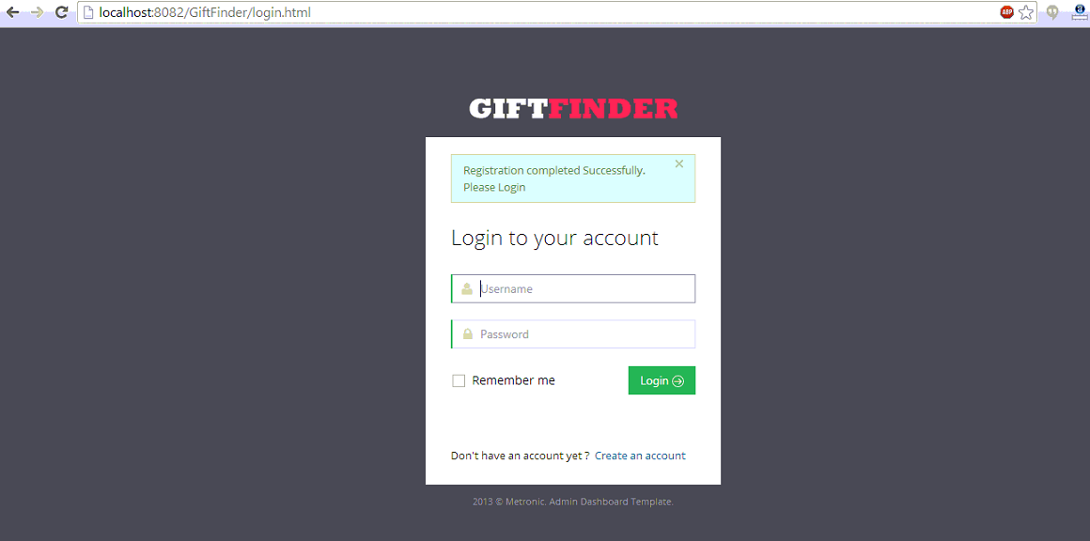

Signing with the details we registered.

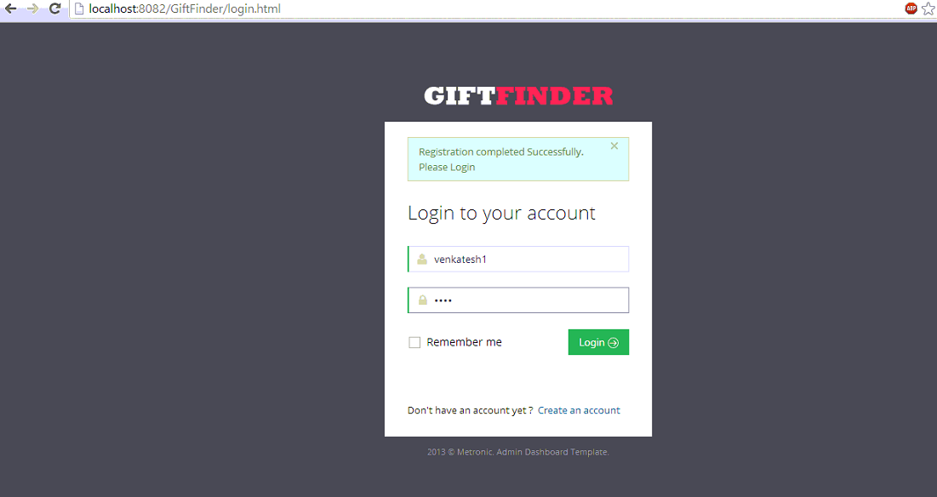

The homepage of the gift finder app after logging in.

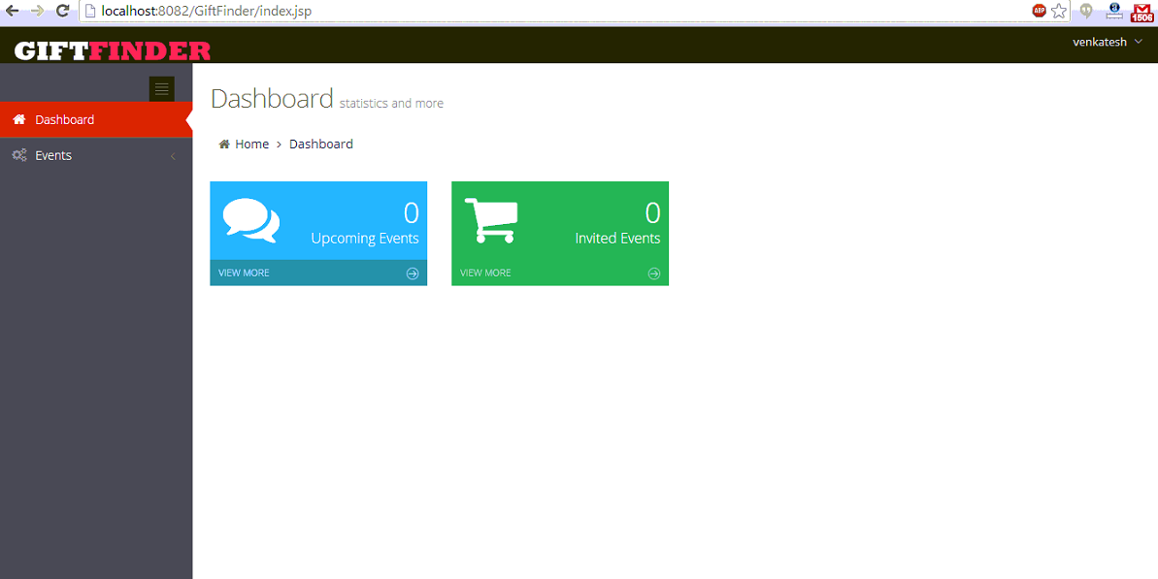

Then creating an event details as shown below

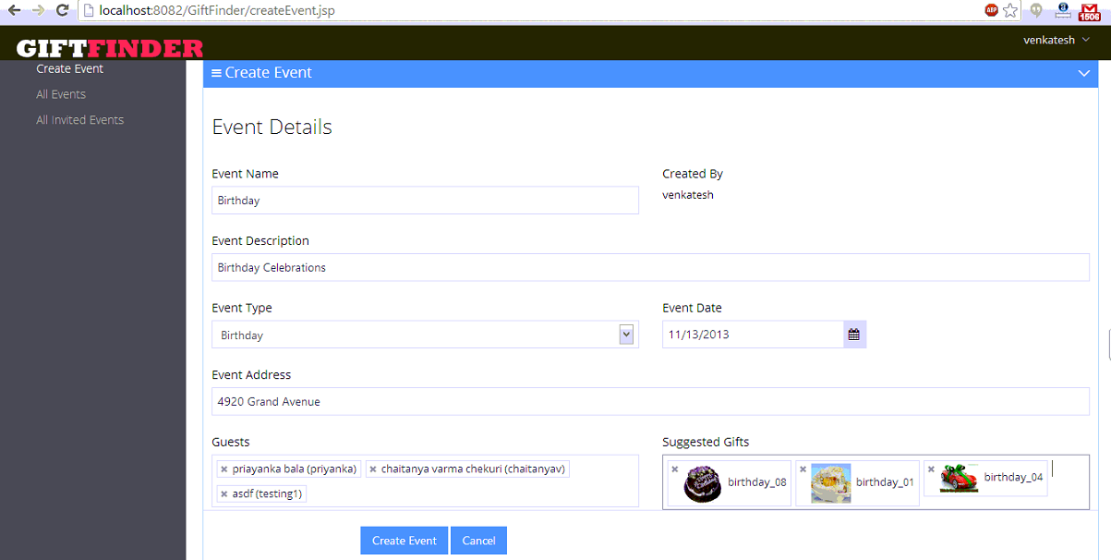

After creating an event the dashboard shows as follows

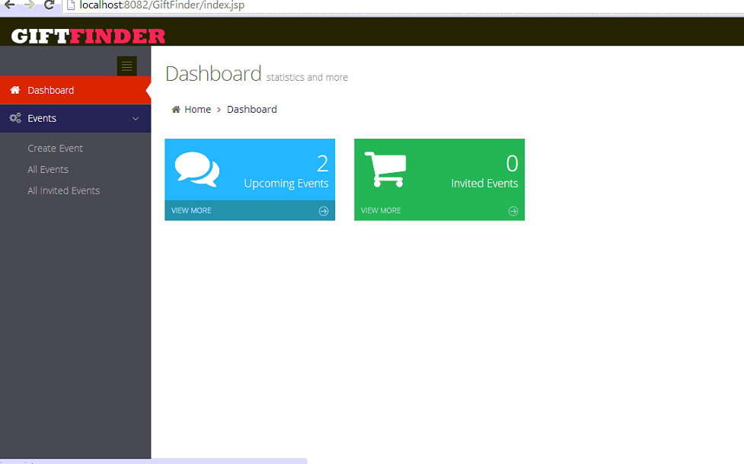

Checking the events list as below

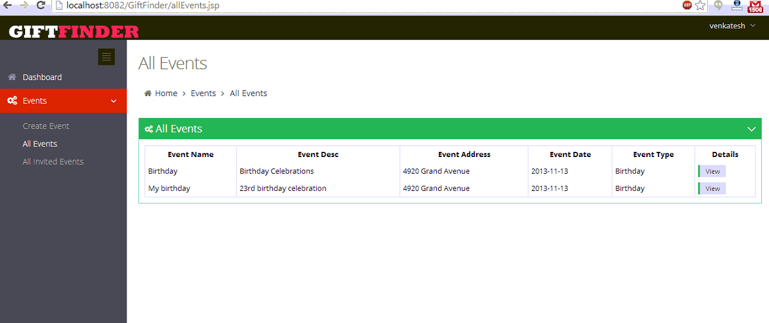

The detailed view of the the event as below

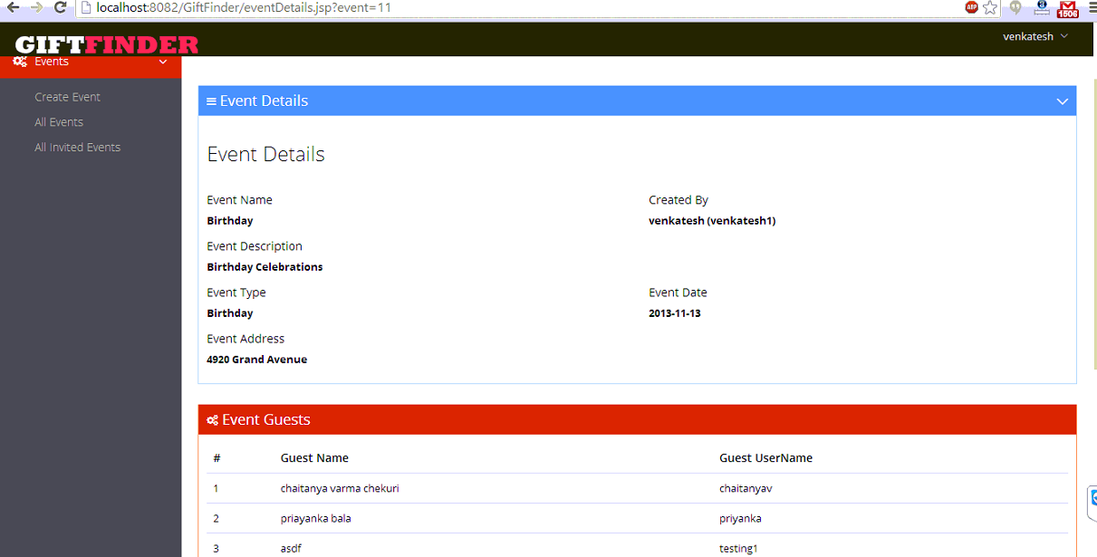

Below shots shows the invited list of the user and the gifts he desired to have.

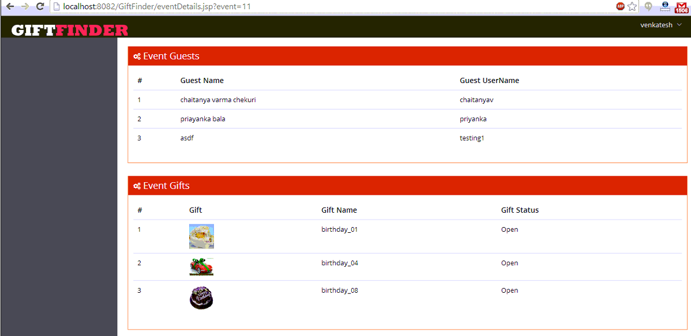

Then logging as different user of which the user invited.

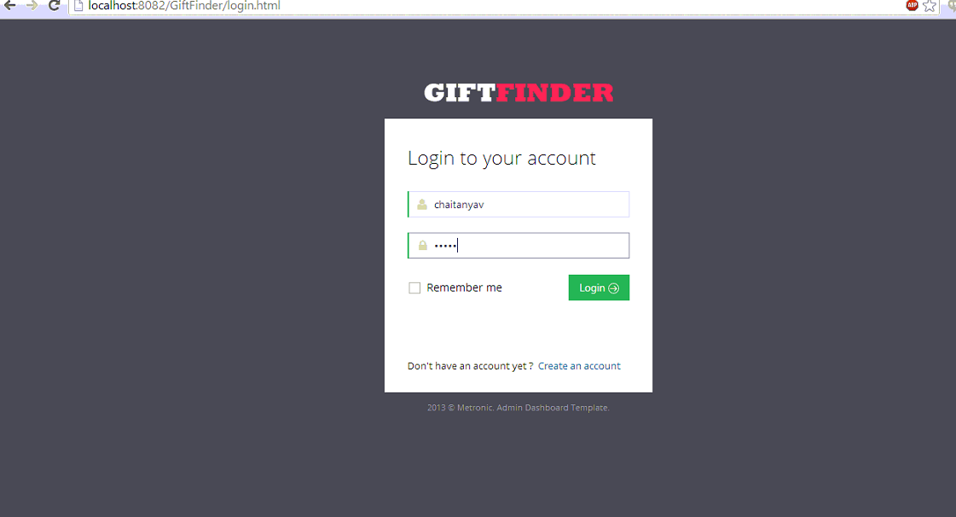

The dashboard for the other user is shown below.

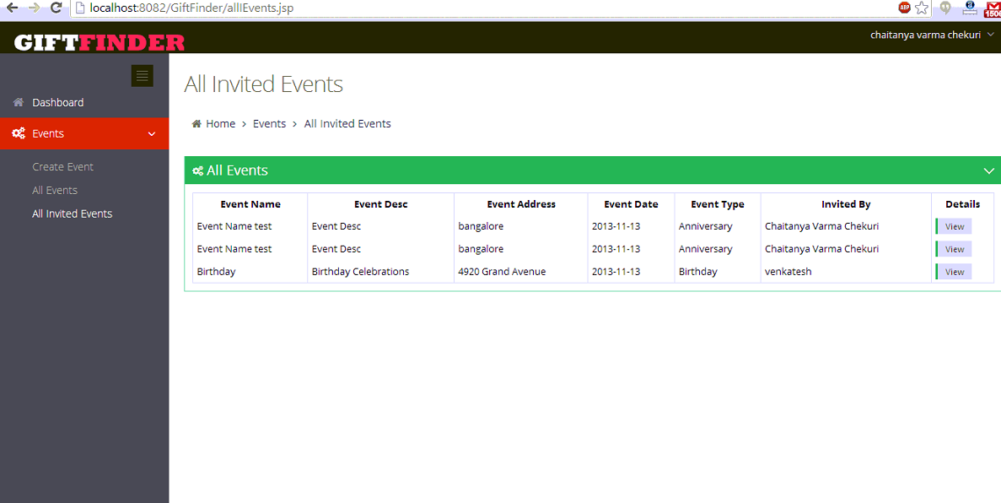

Checking the events of a user.

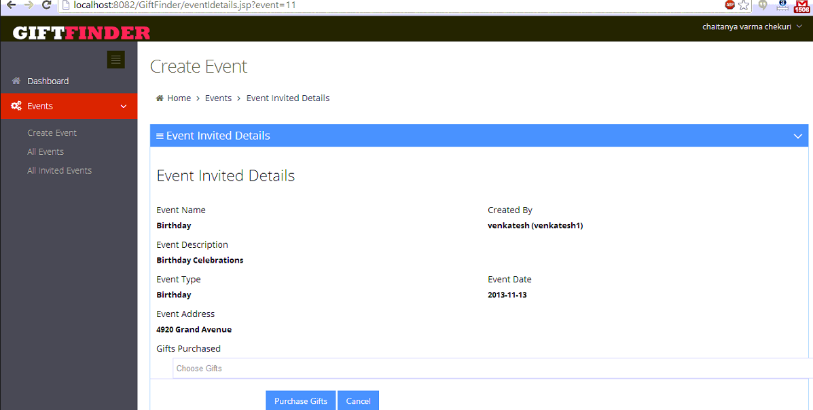

Checking which gifts are available to purchase.

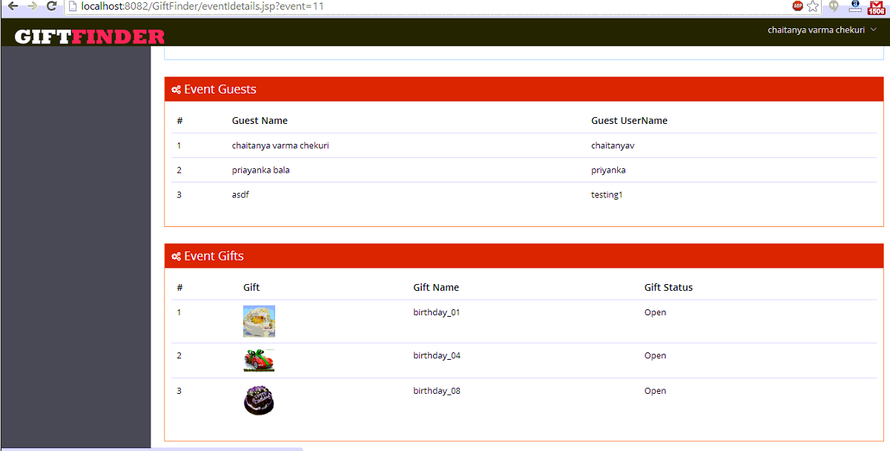

Selects the following gifts to gift user.

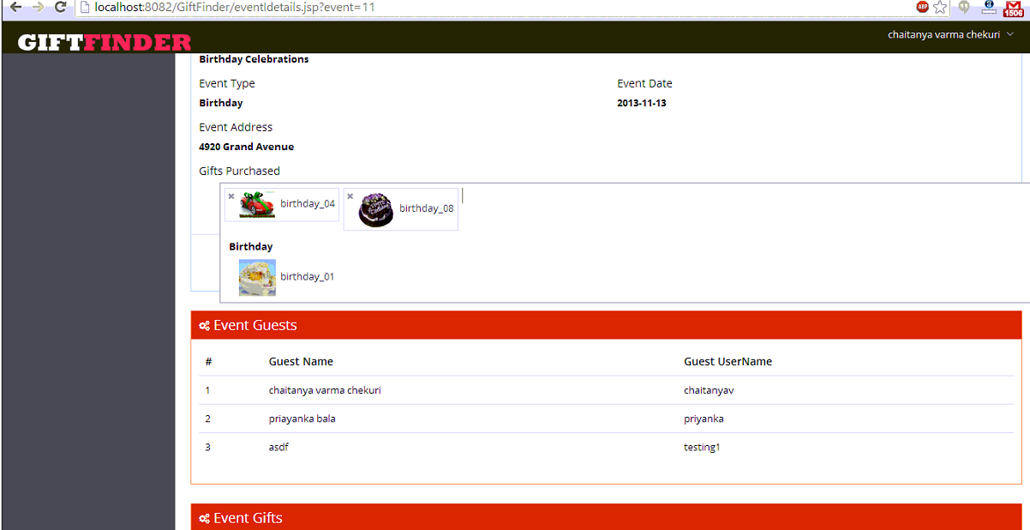

Logging as a first user to check which gifts are available.

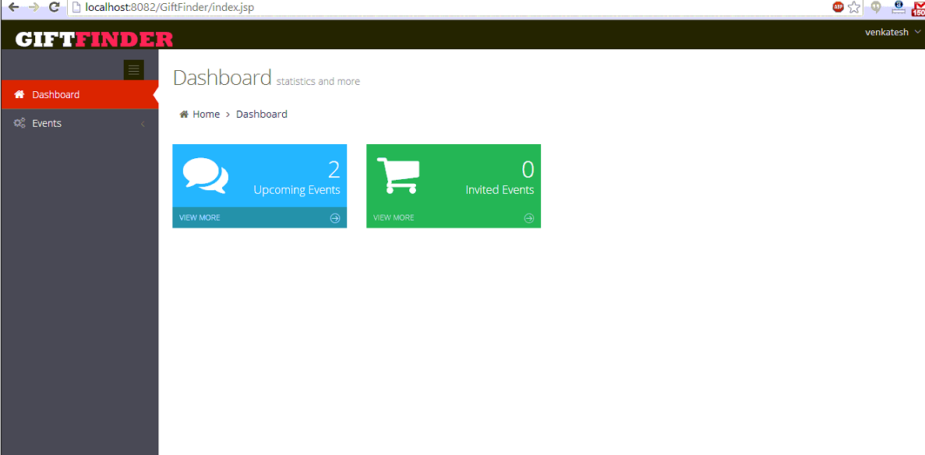

Gift that a second user purchased are shown as purchased as below.

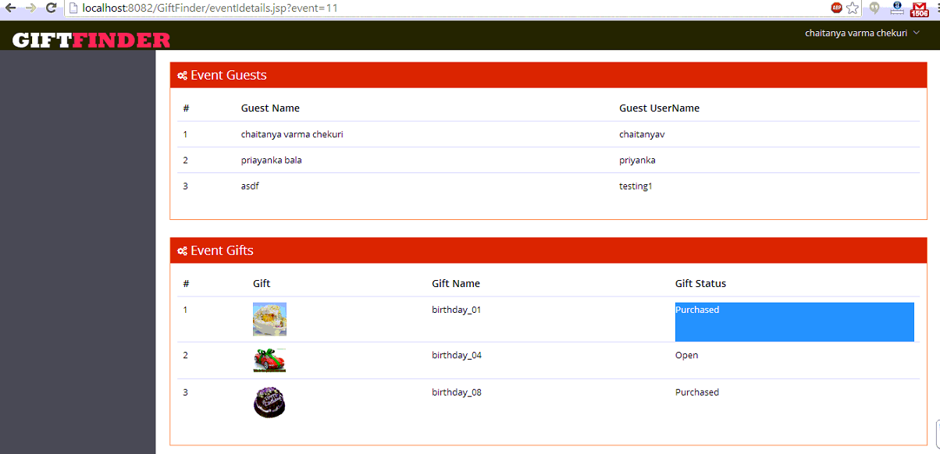

Now a first user checks which gifts he desired to have are available and which are already purchased by friends.

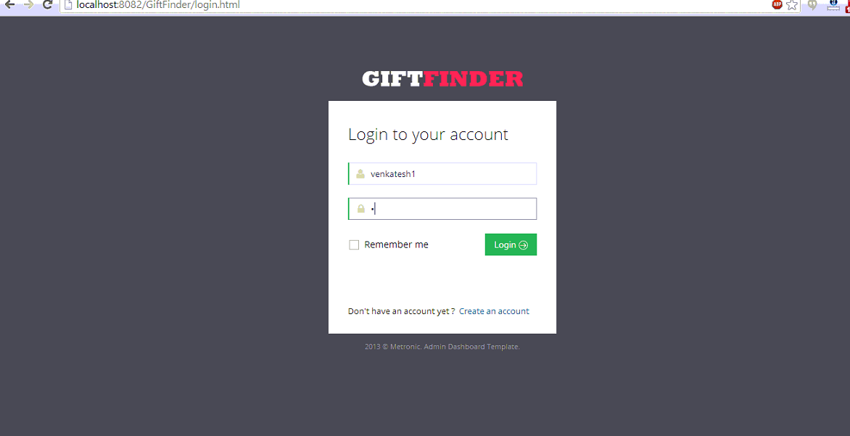

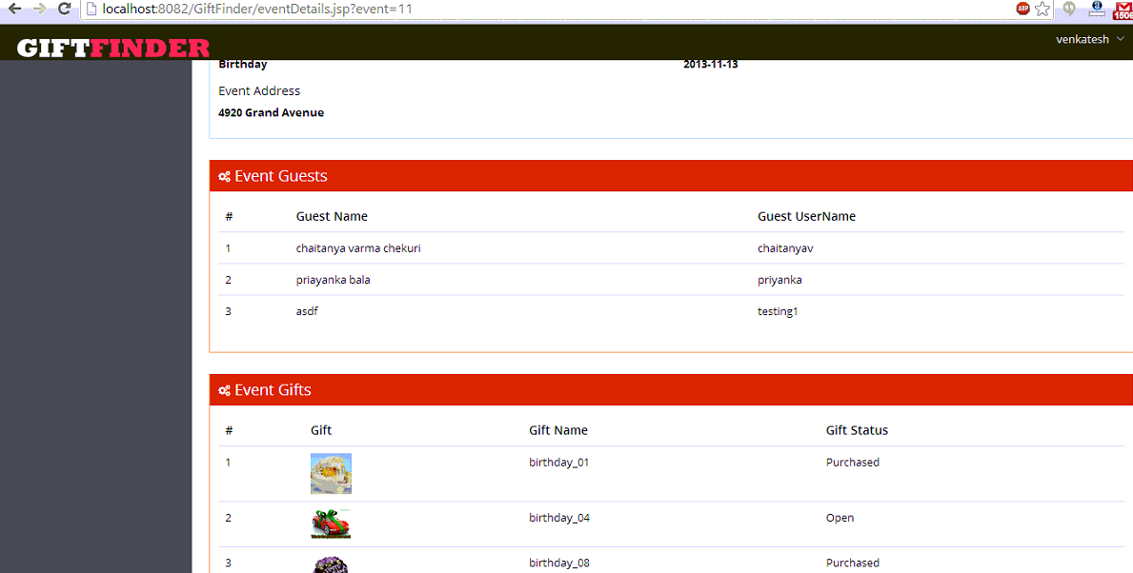

**Software Requirements:**

* Operating system : Windows XP.
* Backend : Jsp ,Servlets
* Frontend : HTML 5, CSS ,JQuery, Ajax
* Data Base : MySQL
* Server : Tomcat 7.0

Limitations:

The limitations in gift finder app is due to lack of time I couldn't able to do the area under taking a picture of the barcode so that a user can upload the images in own profile , but instead I have done placing some images in my database with some images. It can be develop with with advanced features if given some more time.

References: I have used the template for the web page by time constraint , so that I can concentrate more on the development of app.<http://themeforest.net/item/metronic-responsive-admin-dashboard-template/4021469?WT.ac=search_item&WT.seg_1=search_item&WT.z_author=keenthemes>